1838—1839: Sevierville expands once more

With the moving of the post office to Huntsville from Sevierville, Huntsville assumed a new name. This probably did not set well with the founders of the town as George Sanders, John Sanders, Evan S. Polk and others were Whigs and probably took great offense at the name change of Huntsville to Sevierville in honor of Ambrose H. Sevier, a Jacksonian Democrat.

While this political battle was being fought, records indicate that the first meeting of the county court, the honorable John Bowen presiding (1836—1838), was held in a barn located on the farm of Evan S. Polk. According to Goodspeed, a barn belonging to John Sanders was also used when needed. Early records indicate that the first courthouse was constructed around 1837 or 1838.

“The first courthouse stood upon the public square in Huntsville . . .It was built of hewn logs, which to facilitate ventilation or for some other purpose, were never “chinked and daubed.” There was one room, about 30 feet square, open to the roof; it was entered by two doors from the north and south, while the judge’ s table was at the east end. There was neither stove nor chimney, nor need of any, as the sessions were held late in the spring and early in the fall. The benches and tables rested on terra firma for several years, when a puncheon floor was added. This building was erected in 1837—1838 at a cost of $150, provided by a tax levy at the rate of $1.28 per 40 acres of improved land.”
- Goodspeed History, 1889

The Second Courthouse is built on the public square

In 1845, the 2nd courthouse was built on the public square with Evan Polk as the contractor. The building was much more imposing than the log structure that it replaced being made of brick, kilned on the farm of Polk, was two stories and had a brick floor. The 2nd floor had three windows on each side and had six rooms upstairs which provided offices of the County Clerk, Sheriff, a jury room and other offices. The judge and courtroom was on the first floor. Cost of the 1845 courthouse was $4,000. By the end of late 1863, most of Huntsville had been burned to the ground by various invading forces. The Courthouse was gone and all of the county records were taken to Springfield, Missouri, where they were lost or destroyed in great part.

Plans to rebuild the 3rd Courthouse

During the war, the 2nd Madison County Courthouse had been burned along with much of Huntsville. The first sessions of the county court following the war were held in either the home of G. W. Vaughn who served as judge from 1868 – 1872 or the Masonic hall. Quoting from Goodspeed’s History:
On January 28, 1867, James A. Jay was directed by the county court to sell the bricks of the old courthouse. On April 27th, 1868, the court was resolved to build a new courthouse and directed John Carroll to draft a plan for a suitable building. A couple of plans for the courthouse were submitted and on October 30, 1868, $10,000 was appropriated to build it. It was to be a 40 x 60 ft., 2-story building made of stone with a portico on the south side. Unfortunately, the low bid of $12,000 exceeded the amount of money appropriated for its construction.
In January, 1869, a new plan was adopted. The building was to be a wood frame structure, 40 feet square and two stories high. The amount of the Courthouse tax collected in 1869 was $2,666. The building was completed in January, 1871. In early 1871, the new courthouse was opened for business on the public square. The lower floor was separated by a hallway running north and south with four rooms on each side of the hallway, each room about eight ft. square. The courtroom was upstairs along with two small apartments for use as jury rooms.
The first issue of the Madison County Record was published on Saturday, May 31, 1879. The paper was established by Joseph H. Daugherty. A yearly subscription was $1.50 for the four page paper. The newspaper apparently rented one or more of the rooms in the Madison County Courthouse. All went well for the new publication for the first five months.
It must have been a cold day on December 1, 1879. According to reports, editor Daugherty apparently stoked the stove in his printing room so much that it became red hot. The benzene (an extremely volatile liquid solvent) that was used to clean the printing press, ignited and caught Madison County’s 3rd courthouse on fire. Lines immediately assembled to form a bucket brigade and to remove records from the building, most of which were saved. But before the bucket brigade could strengthen to full force, the fire was out of control and the courthouse was lost. It would take some time to repair the press and the Record’s printing was suspended from December 1, 1879 to February 1, 1880.

The 4th Madison County Courthouse
On April 8, 1879, the County Judge John S. Polk appointed a commission, consisting of Dr. Monroe Knight, Albert A. Brodie, William Marrs, F. M. Sams, Dr. Frederick O. Massie, John F. Proctor, G. N. Heflin, and William. A. Gage, to select a new site for the courthouse. Moving the courthouse from the center of the public square to a vacant lot just north of the public square (assumed to be the corner of Short Street and War Eagle) was favored by some of the commissioners but agreement could not be reached by the commission. With the commission not able to come to a consensus, Judge Polk decided to rebuild the courthouse on the original site in the middle of the public square.
Whether the site selection was long and drawn out, construction funds were not foreseeable, or politics were involved, it would be a year for any movement was made on plans for the new courthouse. A new County Judge would be elected in 1880. In March 1880, Dr. Knight and W. A. Gage were asked by new Judge, William Deramiah, to draw up plans for a new courthouse. For whatever reason, finding a building commissioner seemed to be a problem. Finally, in April, 1881, John R. Simpson was appointed to supervise the construction of the new courthouse.
William A. Gage was awarded the general contract on May 24, 1881 with a bid of $3,000. The building was to be constructed of brick, 40 x 50 feet, with a height of 26 feet from the foundation to the roof. For the first time in courthouse history, the courthouse was to have four doors, accessible from each direction. The lower floor was divided into four large rooms. The courtroom would occupy the entire second floor. On February 6, 1882, S. P. Jackson was awarded the contract to finish and furnish the interior of the new courthouse at a cost of $1,000. The new courthouse would be ready by the fall.
During the next 8 years, several references to the condition and upkeep of the new courthouse were made. The steps to the east entrance began to deteriorate to the point they warranted replacement. The roof began to leak, the yard around the building was littered and need of attending, and many of the windows were broken, no doubt a result of vandalism, whether alcohol or politically motivated. The editor of the local newspaper commented that the county should take better care of its public building.
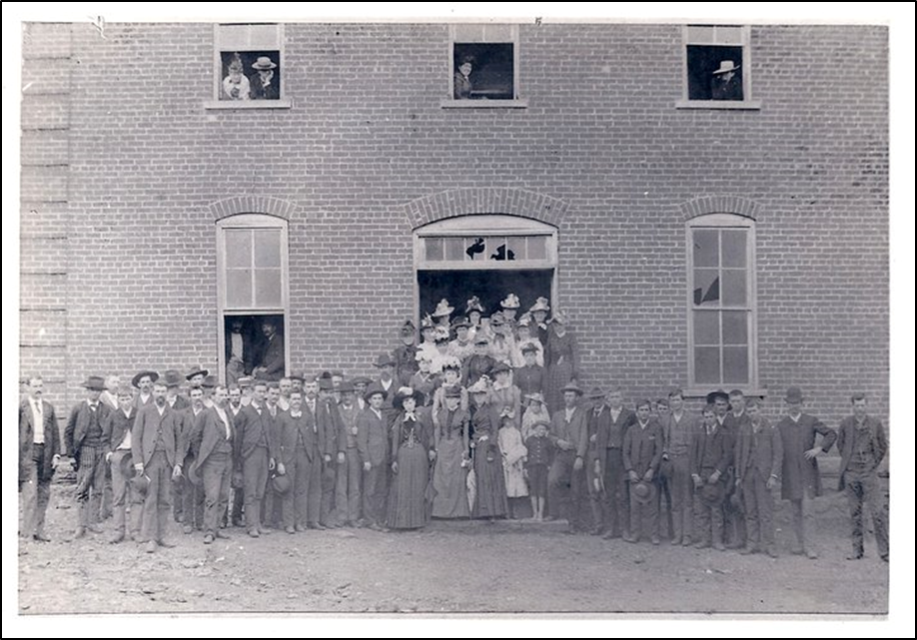

Just before midnight on Saturday, November 29, 1902, the north side of the Huntsville square was well ablaze before anyone noticed. Before it was over, a total of fourteen businesses including the Madison County Bank and the Madison County Courthouse would be destroyed.

Huntsville prepares to construct its 5th Courthouse
County Judge Stroud began to immediately make plans for the construction of a new courthouse. The judge favored the issuance of some sort of bond issue but apparently there were constitutional issues with that proposal and other means for financing the construction would have to be found. He appointed a committee to meet in Huntsville on December 13th to discuss the issue composed of William Shofner, A. A. Brodie, Lon Garrett, Caleb Cox, J. H. Dunnaway, H. P. McCracken, W. A. Dotson, W. R. Brashears, Alex Martin, and Alfred Hawn.
By the end of January, 1903, the plans and apparently the financing of a new courthouse had been approved as a notice for bids was published in the January 28, 1903 edition of the Madison County Democrat and the Huntsville Republican. Sealed bids were to be delivered to the building commissioners, consisting of Sam Nunneley, G. W. Vaughan, and Samuel B. Gilliland no later than February 12th.

The further discussion and clamoring of St. Paul residents became a little more vocal at this time about the possibility of moving the county seat from Huntsville to St. Paul. After all, now would be a good time to make the move as a new courthouse would have to be built anyway and Huntsville was not even an incorporated town. Huntsville residents would argue that the county seat needed to be located near the center of the county making it equally accessible to all of its citizens. The editor of the St. Paul Mountaineer argued that if a line was drawn east to west through Huntsville, there were less than 1,000 votes in the entire area north of Huntsville, which argument was aggressively addressed by Huntsville businessmen and other prominent citizens as incorrect.
The discussion would come to an end with the decision to rebuild the 5th Madison County Courthouse on the now vacant E. A. Routh lot, on the north side of the Huntsville public square, at the corner of College and War Eagle streets.
Although an advertisement for bids was issued in early 1903, it does not appear that construction was started that year or there were delays in the construction. The contract for the outside stone work was awarded to the firm of McGuire and Adams. For reasons unknown, possibly financial, the subcontractors for the stone work sold out to Huntsville residents Hamilton, Nunneley and Routh, no doubt being J. P. Hamilton, Sam Nunneley and E. W. Routh. It was reported that as soon as workers could be secured, work on the courthouse would resume. Madison County’s and Huntsville’s 5th Courthouse was completed in April, 1906. It had been nearly four years since fire had destroyed the fourth courthouse and this time, it was not located inside the public square and it was constructed of stone, rather than wood frame.
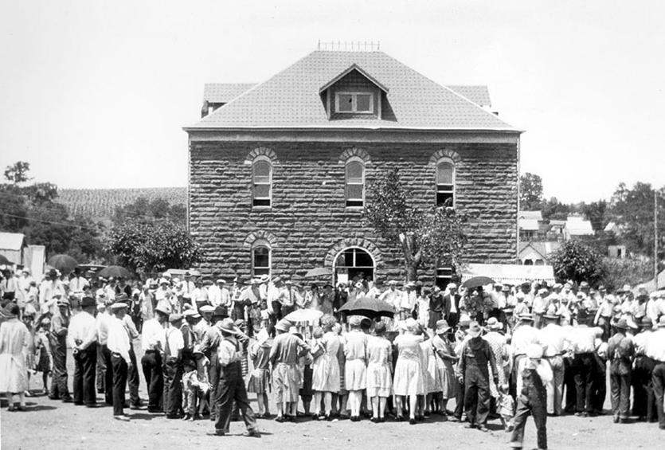
Note: electric light would be added in 1914 in exchange for the County allowing a local entrepreneur to show movies in the courtroom weekly.

Public Works Administration continues to build in Madison County

In the fall of 1937, county officials began thinking about future county facilities available under the New Deal. In the fall of 1938, the Public Work Administration announced that it would fund 45% of the cost of a new courthouse and jail if the county could come up with the other 55%. The courthouse located on the north side of the Huntsville square was now about 35 years old and was inadequate to meet the present and future needs of the county. In order to finance the construction, the citizens of the county would have to approve a bond issue in order to finance its share.
In 1938, the county was still paying off a prior bond issue that had been issued to help the county restructure its debts and place the county on a cash basis. That bond issue was set to expire in 1940. By voting to continue that bond issue and voting an additional 1.5 mils for two and a half years, the county would be able to come up with the required matching funds to receive the P.W.A. grant. The cost for the new courthouse and jail was set at $89,000. The county’s share of the cost would be about $49,000. Voters would be asked to approve a bond issue at the November 8, 1938 election. County Judge W. J. Drake and project attorney, Maupin Cummings set about to convince county voters of the need of the new courthouse and now would be the time while the P.W.A. was offering to assist with the funding.
By a vote of 1,211 for construction and 1,043 against, Madison County voters approved the construction and the bond issue. Construction was to begin on December 30, 1938, on a lot, at the current site of the Simpson-Riggs Funeral Home, west of the new Standard Oil Gas Station. R.A. Hughes of Fayetteville was awarded the general contract with the building designed by architects T.E. Shelton of Fayetteville and E. Chester Nelson of Ft. Smith.

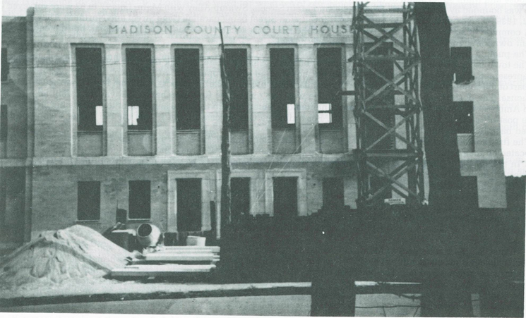
Figure 140 -The Sixth Madison County Courthouse under construction in 1940

Figure 142 -The Madison County Courthouse shortly after its dedication on November 30, 1939. 